**Controllers**

* Controllers in k8s control/maintain state of k8s objects

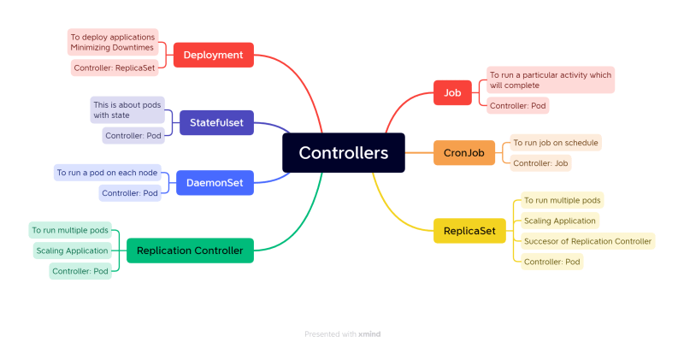

**ReplicaSet**

* <https://kubernetes.io/docs/concepts/workloads/controllers/replicaset/> for ReplicaSet official docs
* ReplicaSet is controller which maintains count of Pods as Desired State

**RS-Activity1 Create 3 nginx pods**

* <https://github.com/asquarezone/KubernetesZone/commit/77c8c9d804b4a69d9d4df9691dc696a740bf04ab> for the nginx rs manifest without selector  
  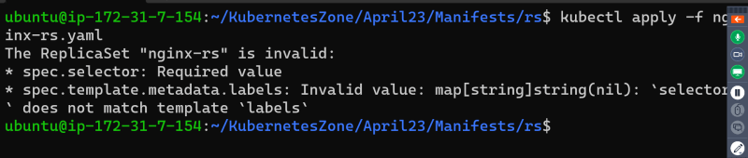
* temporary workaround for adding selectors. <https://github.com/asquarezone/KubernetesZone/commit/e52430db3bcf4e92990495741a5f4f1bc95db2ce> for the changes added
* Now apply the manifest  
  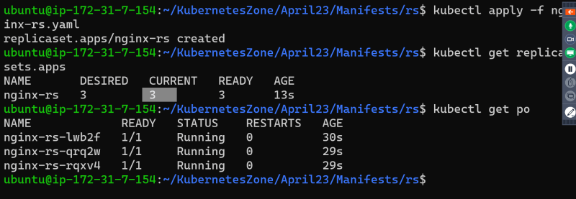
* Lets change the replica count  
  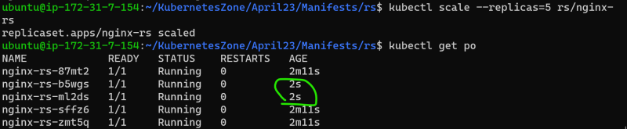
* We can increase (scale out) as well decrease (scale in) the replica count  
  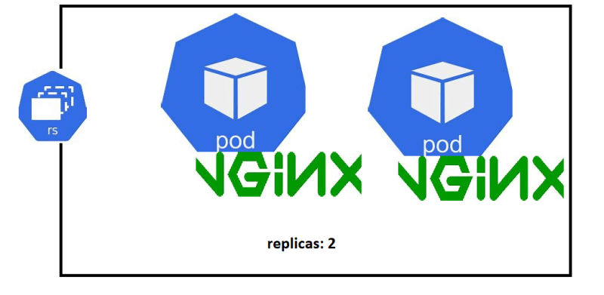

**RS-Activity2 Create 5 Pods with jenkins and alpine in one Pod**

* <https://github.com/asquarezone/KubernetesZone/commit/d964fd4084e930a3103e5cc2cf3ecb1978763459> for the manifest
* Apply the manifest  
  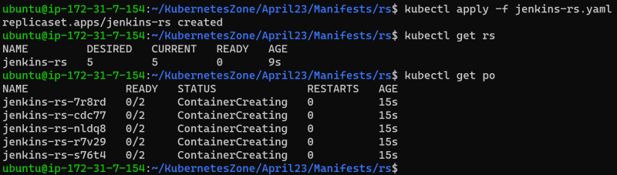  
  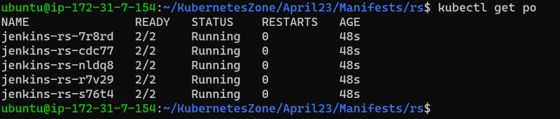
* Get events from describe rs  
  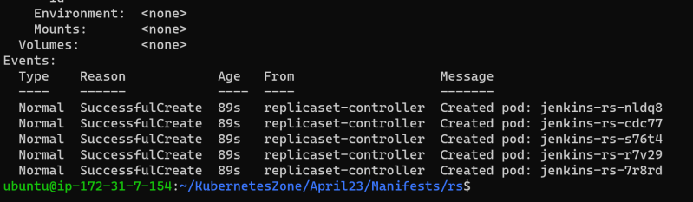
* Now delete a pod manually  
  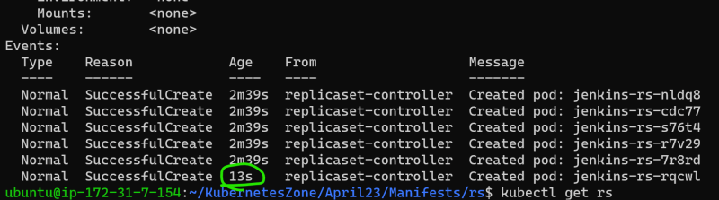

**Labels**

* <https://kubernetes.io/docs/concepts/overview/working-with-objects/labels/> for official docs
* Labels are key value pairs that can be attached as metadata to k8s objects.
* Labels help in selecting/querying/filtering objects
* Labels can be selected using
  + equality based <https://kubernetes.io/docs/concepts/overview/working-with-objects/labels/#equality-based-requirement>
  + set based <https://kubernetes.io/docs/concepts/overview/working-with-objects/labels/#set-based-requirement>

**Label Activity 1. Create a nginx pod with label**

* Lets create a nginx pod with label app: nginx
* <https://github.com/asquarezone/KubernetesZone/commit/033ced70c7020ca9f843439dd42c9b4243fcb335> for the pod spec with labels  
  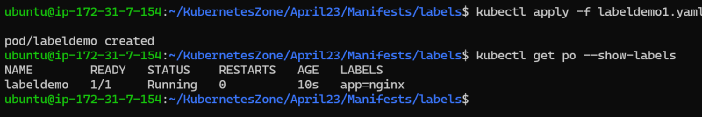
* Lets run some other pods using declartative  
  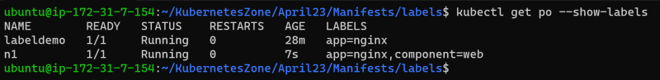  
  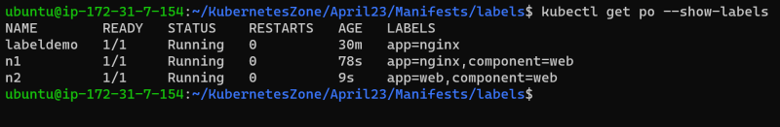
* Selectors  
  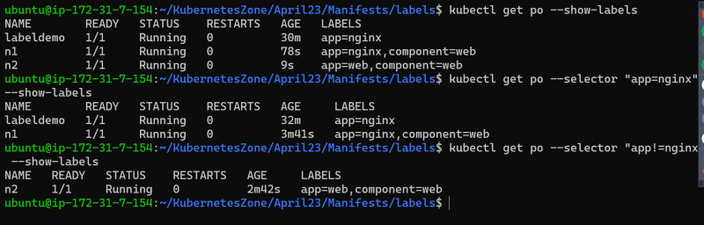  
  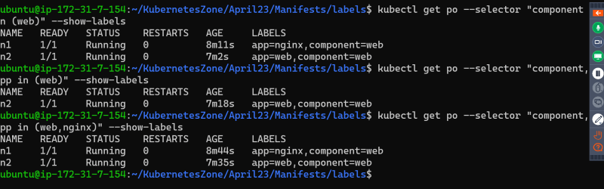
* Create 5 pods with label app=jenkins  
  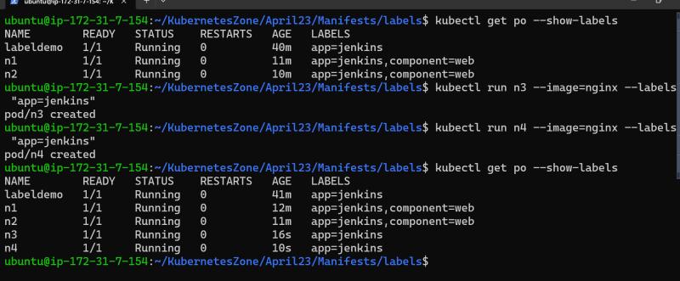
* Now run the replicaset with 5 replicas

---

apiVersion: apps/v1

kind: ReplicaSet

metadata:

name: jenkins-rs

spec:

minReadySeconds: 5

replicas: 5

selector:

matchLabels:

app: jenkins

template:

metadata:

name: jenkins

labels:

app: jenkins

spec:

containers:

- name: jenkins

image: jenkins/jenkins:lts-jdk11

ports:

- containerPort: 8080

- name: alpine

image: alpine:3

args:

- sleep

- 1d

* Jenkins rs didnt create any pod as there were 5 pods matching label selector. we had deleted one pod which lead to creation of jenkins pod from the template section in above manifest  
  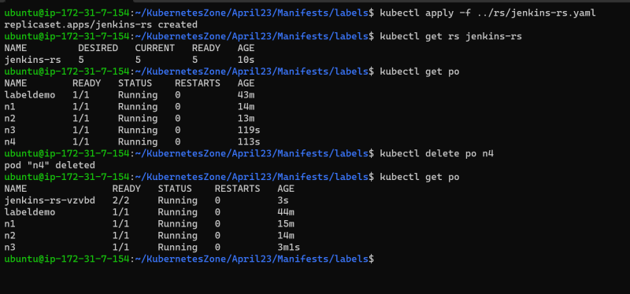
* ReplicationController only allows equality based selectors where as ReplicaSet supports set based selectors also

